1.Deploy an application using a Deployment with 3 replicas and a rolling update strategy.
Steps:
- Create the Deployment YAML file
vi deployment.yaml
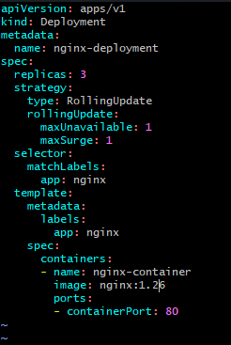

- Deploy the service
Kubectl apply -f deployment.yaml
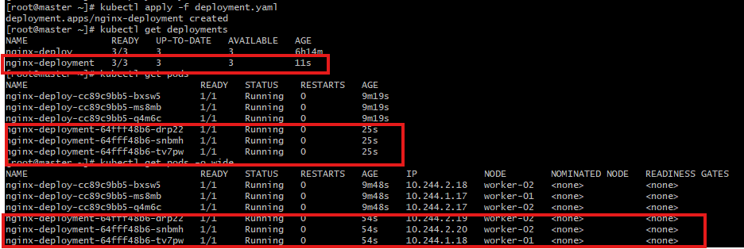

- Describe the Deployment
kubectl describe deployment nginx-deployment

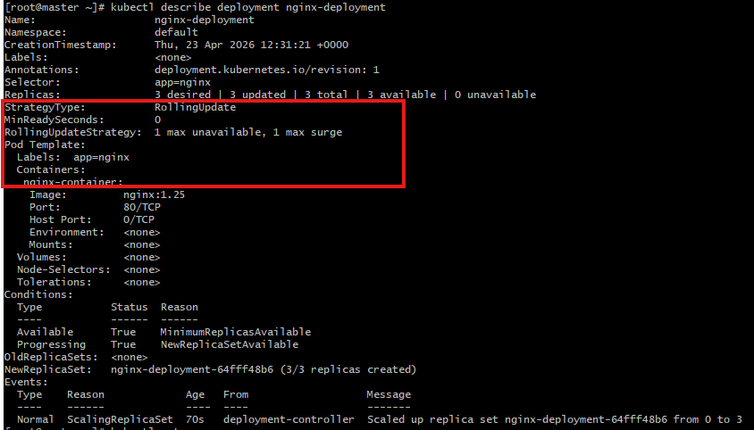

- Watch the rolling update live
kubectl rollout status deployment/nginx-deployment

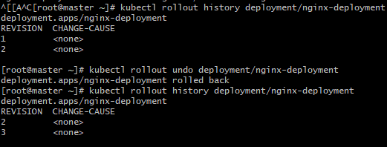

2. Configure a Deployment with a Recreate strategy and observe the downtime.

Steps:

1) Create the Deployment YAML with Recreate strategy

Vi recreate-deployment.yaml

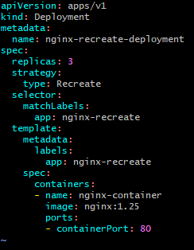

2)Deploy the application
Kubectl apply -f recreate-deployment.yaml
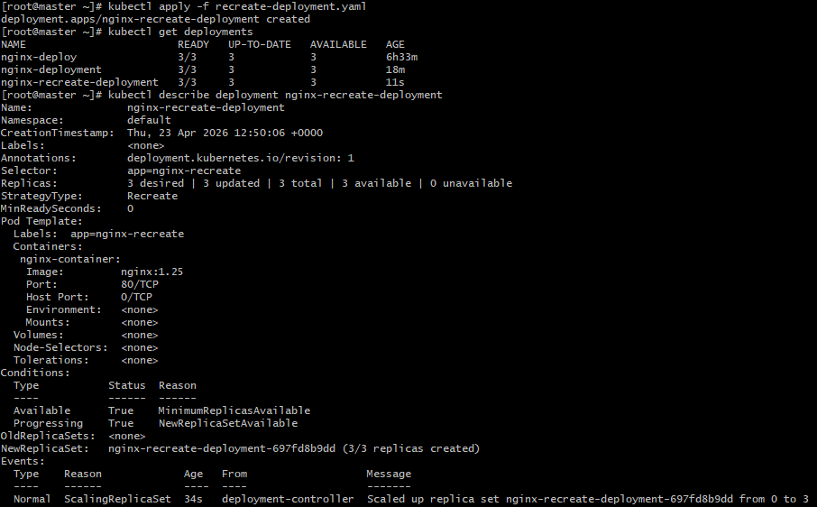

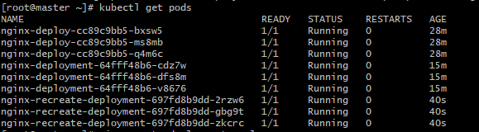
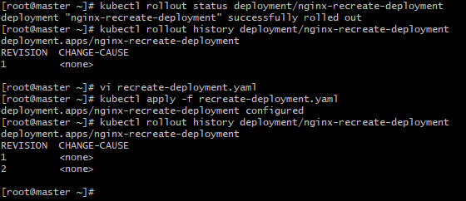

3. Update an existing Deployment and perform a rollback to the previous version.

Steps:
- Create the initial Deployment YAML
vi deployment.yaml


2)Deploy the application
Kubectl apply -f deployment.yaml
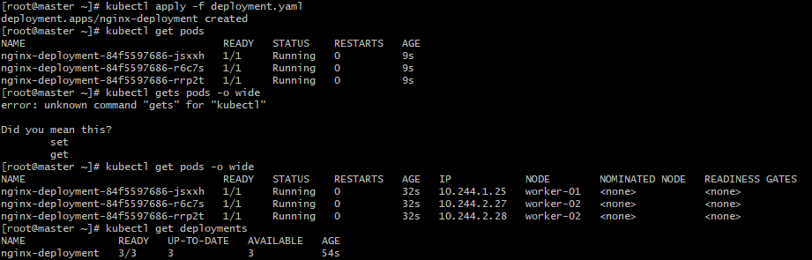

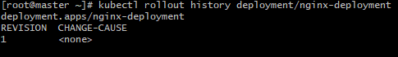

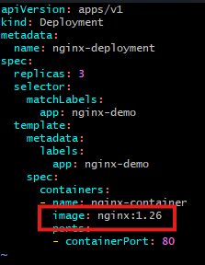

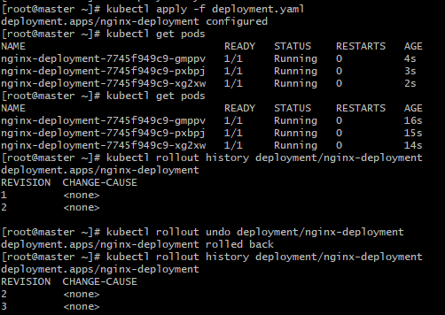

4.Modify a Deployment to add resource requests and limits for CPU and memory.
Steps:
- Edit the Deployment YAML
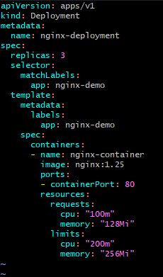

2)Deploy the yaml file
Kubectl apply -f deployment.yaml
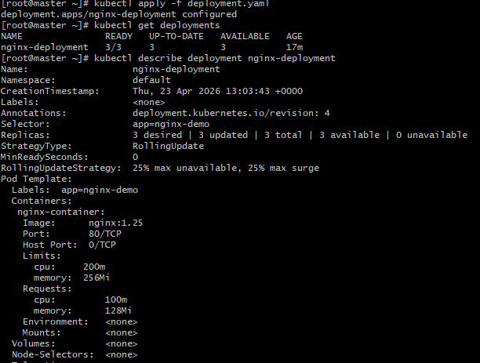

3)Verify the running Pod resource settings
kubectl describe pod <pod-name>
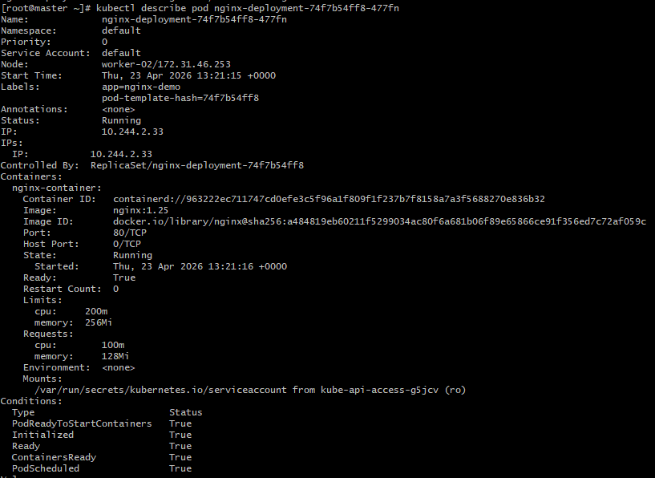
5.Create a Deployment with MaxSurge and MaxUnavailable configurations.

Steps:

- Create Deployment YAML
vi deployment.yaml
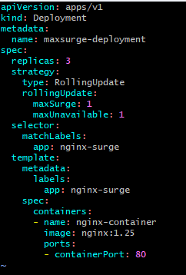

- Deploy the pod
Kubectl apply -f deployment.yaml
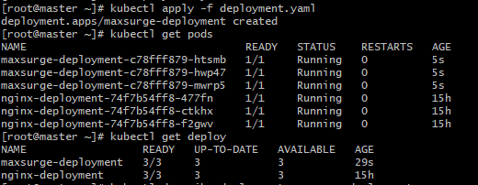

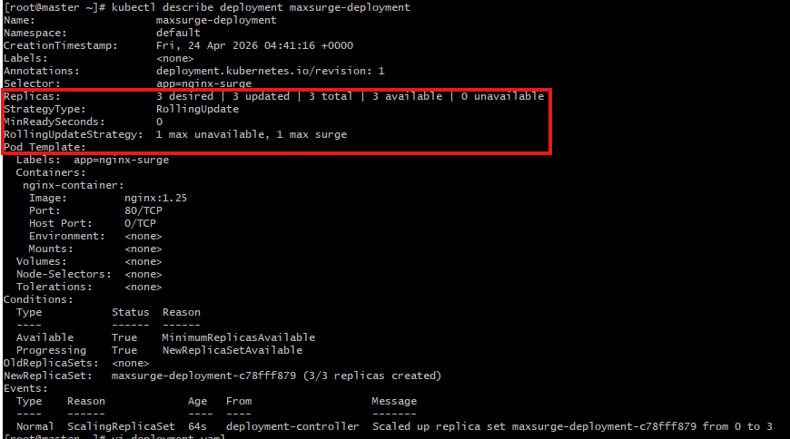

6.Set up a Deployment with a custom revision history limit.
Steps:
- Create Deployment YAML
Vi revision.yaml
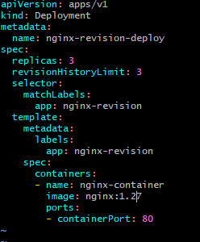

2)Deploy the application
Kubectl apply -f revision.yaml
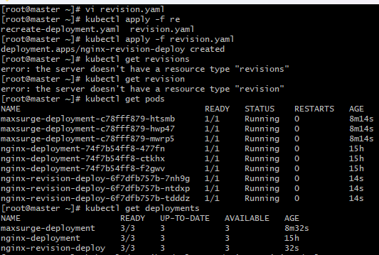

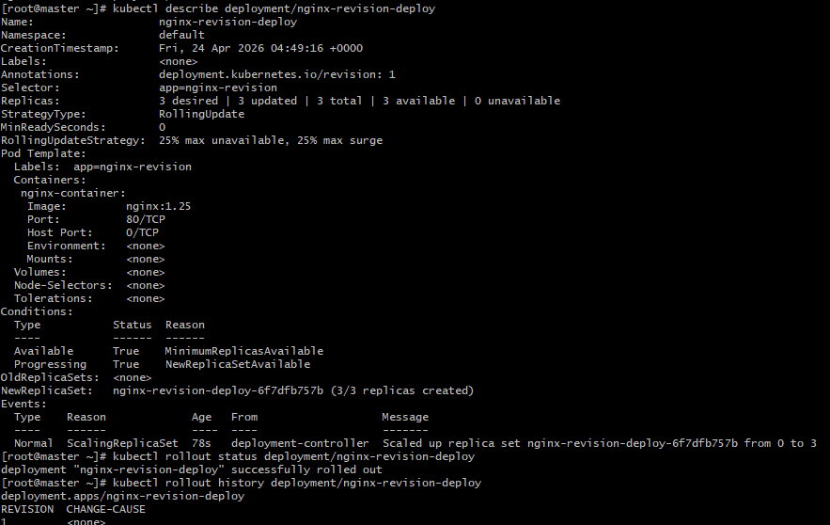
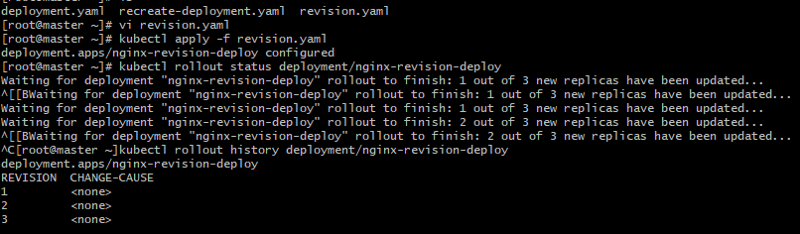

7. Pause a Deployment during an update, and then resume it.

Steps:
- Create Deployment YAML
Vi pause.yaml
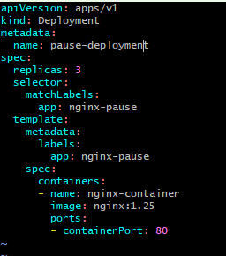

- Deploy the pod
Kubectl apply -f pause.yaml
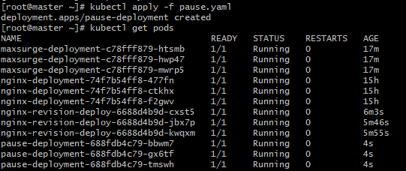

- Pause the deployment
Kubectl rollout pause deployment/pause-deployment
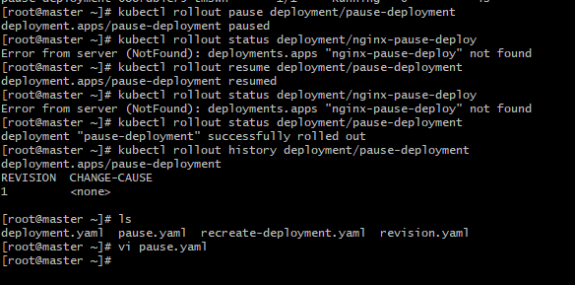

8. Create a pod using resource requests for memory and CPU, and observe how the scheduler assigns it to a node.
